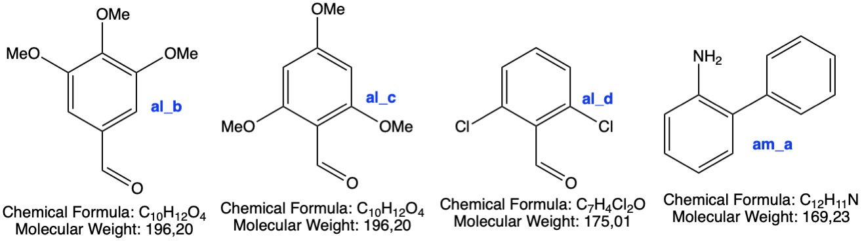

Compound | mg | Molecular formula | MW | Antibacterial  (B. Subtilis, S. Aureus, S. Pyogenes, E. Coli, P. Aeruginosa, S. Typhi) | Antioxiodant  (DPPH)
al_b | x.xx | C10H12O4 | 196.20 | Yes | Yes
al_c | x.xx | C10H12O4 | 196.20 | Yes | Yes
al_d | x.xx | C7H4Cl2O | 175.01 | Yes | Yes
am_a | x.xx | C12H11N | 169.23 | Yes | Yes

Date:

