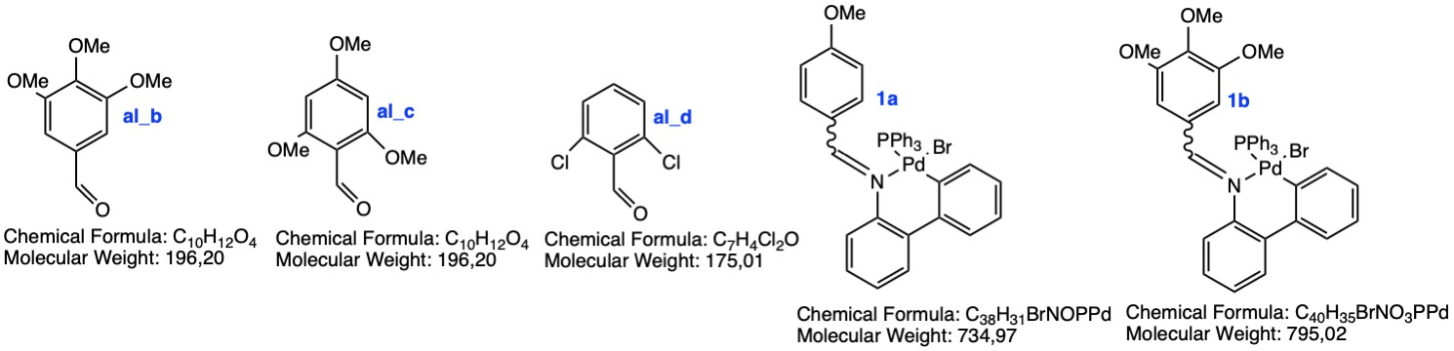

Compound | mg | Molecular formula | MW | DNA  migration | Topoisomerase I  inhibition | Topoisomerase II  inhibition | Cathepsin B  inhibition
al_b | x.xx | C10H12O4 | 196.20 | Si | Si | Si | No
al_c | x.xx | C10H12O4 | 196.20 | Si | Si | Si | No
al_d | x.xx | C7H4Cl2O | 175.01 | Si | Si | Si | No
1a | x.xx | C38H31BrNOPPd | 734.97 | No | Si | Si | No
1b | x.xx | C40H35BrNO3PPd | 795,02 | No | Si | Si | No

Data:

