TITLE in ARIAL BOLD 12 pt. (please maintain the full title of your lecture or poster)
AuthorNameSpaceSurnameinArial11pt,⁰ M. Capdevila¹ (underline the presenting author), A. Caubet²
¹ Dept. Química, Universitat Autònoma de Barcelona, E-08193 Bellaterra, Barcelona (Spain); Merce.Capdevila@uab.es
² Dept. Química Inorgànica, Universitat de Barcelona, E-08028 Barcelona (Spain)

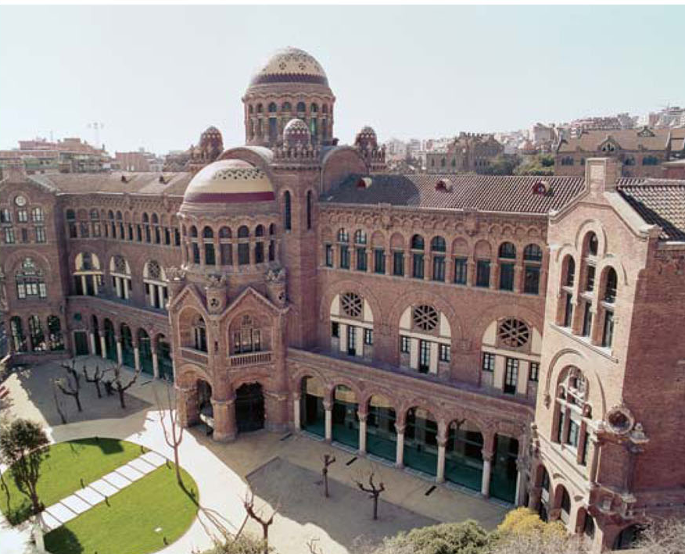
Please, read carefully: Here you can start adding your contribution (one contribution, one page!) with 2 cm margins on each side. Use Arial 10 pts throughout your text. All paragraphs must be justified. If references are added, please use the [1] or [2,3] modes, to be included, where pertinent, after punctuation.[4]
Figures (black-and-white only!) can be included. Insert them in the main body of the text as it is shown.
Here you can continue adding your text … At the end, it should contain a conclusion. Please, do not exceed one page.
The final file has to be saved with the surname of the presenting author, followed by a low line to indicate the topic number (T1 to T6) and the type of communication (plennary, keynote, oral communication or poster), in MSWord 2003 or 2007 format (example: capdevila_T1poster.doc or .docx).
Finally, you should submit it to the following e-mail address “abstract_ISABC11@antares.qi.ub.es” as an attached file.

Acknowledgements and references should be typeset in Arial 8 pts as is shown below.

Acknowledgements
Financial support from the ZZZZ is acknowledged.

References
[1] A. Pérez, B. Fernández, C. Ramírez, J. Am. Chem. Soc., 2011, 137, XXX-XXX.
[2] J. S. Casas, V. Moreno, A. Sánchez, J. L. Sánchez, J. Sordo, Química Bioinorgánica. Ed. Síntesis, Madrid, 2002.
Happy Writing!

